# Combined Bug Reports

This document contains a consolidated list of all major bugs found during the testing of the "Buggy Playground" application.

### **Bug #1: Form Submission with Empty Required Fields**

* **ID:** BUG-01
* **Severity:** High
* **Environment:** Windows 11, Chrome Browser
* **Steps to Reproduce (STR):**
  1. Navigate to the "Sign-up & Profile Wizard."
  2. Leave the "Full Name" and "Date of Birth" fields empty.
  3. Fill in the other fields with valid data.
  4. Click the "Next" button.
* **Expected Result:** The form should not proceed. An error message should appear below the empty fields, prompting the user to fill them in.
* **Actual Result:** The form proceeds to the "Review" stage with empty values for name and dob.
* **Evidence:** 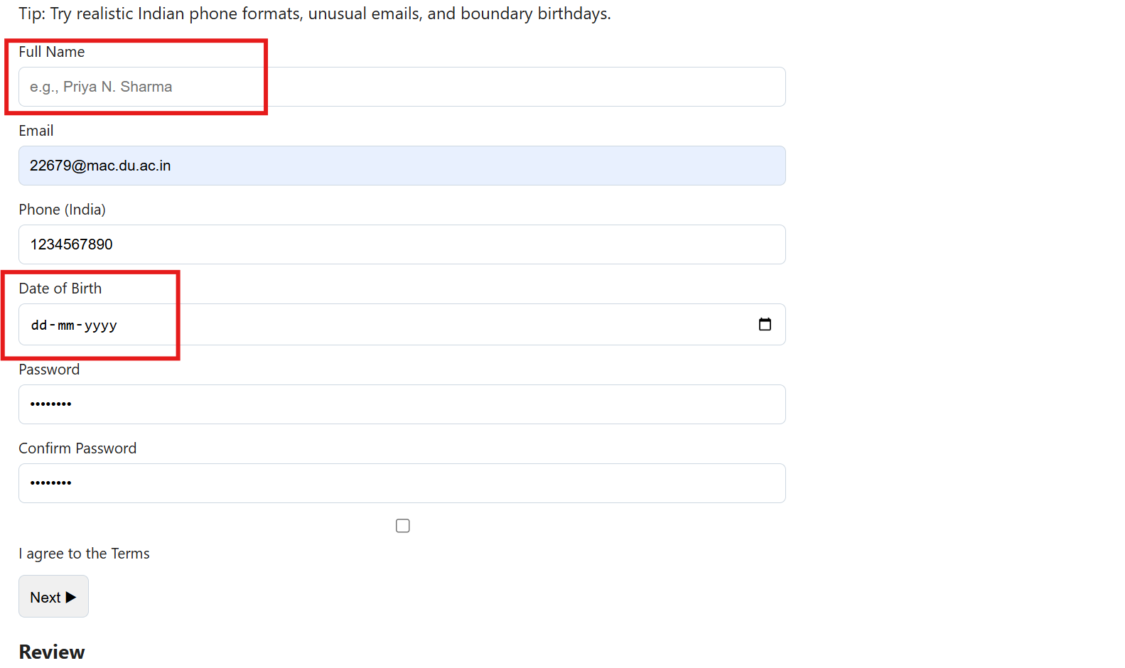

### **Bug #2: Phone Number Input is Malformed on Submission**

* **ID:** BUG-02
* **Severity:** High
* **Environment:** Windows 11, Chrome Browser
* **Steps to Reproduce (STR):**
  1. Navigate to the "Sign-up & Profile Wizard."
  2. In the "Phone (India)" field, enter a number with the country code and a space (e.g., +91 7654192689).
  3. Proceed to the "Review" stage.
* **Expected Result:** The phone number data should be sanitized and stored correctly as a standard 10-digit number (e.g., "7654192689").
* **Actual Result:** The application fails to sanitize the input, resulting in malformed data ("7654192689,") in the review section.
* **Evidence:** 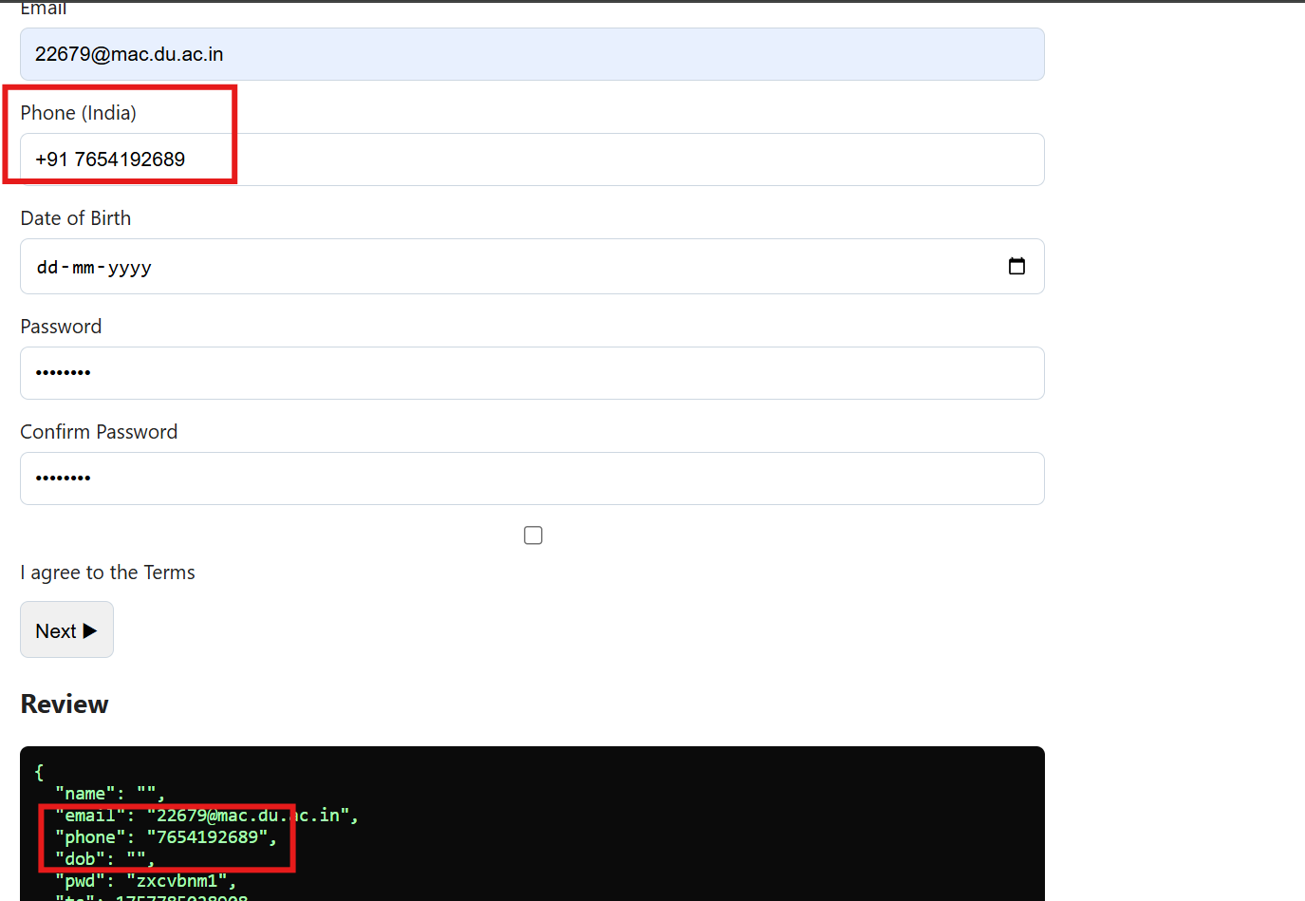

### **Bug #3: Confusing Error for Invalid Future Date**

* **ID:** BUG-03
* **Severity:** Medium
* **Environment:** Windows 11, Chrome Browser
* **Steps to Reproduce (STR):**
  1. Navigate to the "Sign-up & Profile Wizard."
  2. In the "Date of Birth" field, enter a nonsensical future year (e.g., 275760).
* **Expected Result:** A clear error message should be displayed, such as "Date cannot be in the future" or "Please enter a valid year."
* **Actual Result:** A confusing and irrelevant pop-up alert appears with the message "Must be 18+".
* **Evidence:** 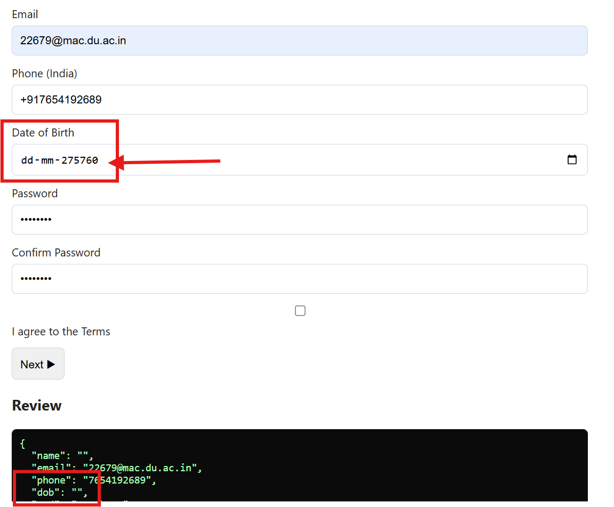

### **Bug #4: "Agree to Terms" Checkbox is Not Required**

* **ID:** BUG-04
* **Severity:** Medium
* **Environment:** Windows 11, Chrome Browser
* **Steps to Reproduce (STR):**
  1. Navigate to the "Sign-up & Profile Wizard."
  2. Fill in all fields with valid data but leave the "I agree to the Terms" checkbox unchecked.
  3. Click the "Next" button.
* **Expected Result:** The form should not proceed. An error should prompt the user to agree to the terms.
* **Actual Result:** The form proceeds to the "Review" stage without requiring the user's agreement.
* **Evidence:** 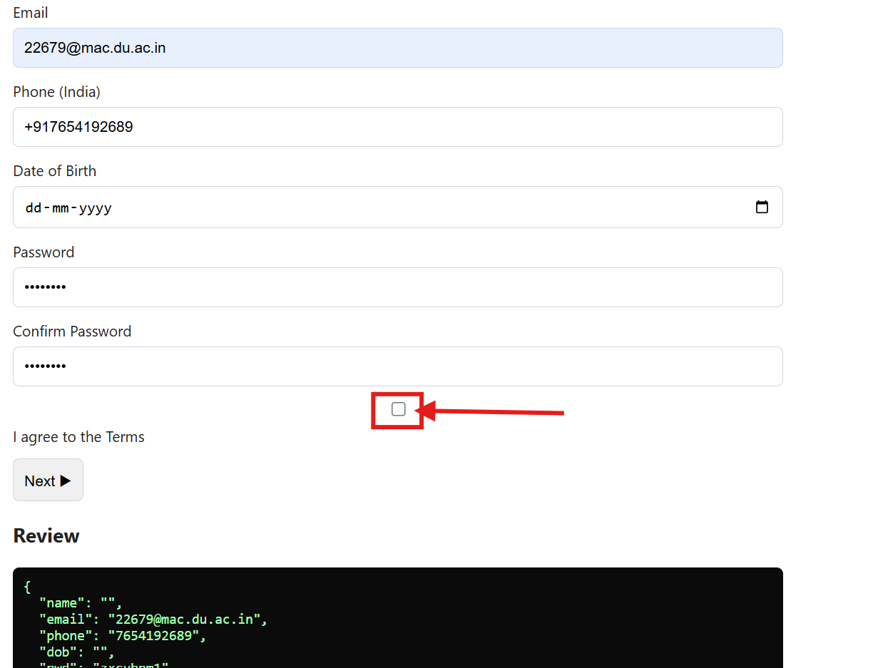

### **Bug #5: Expense Splitter Division by Zero Error**

* **ID:** BUG-05
* **Severity:** Critical
* **Environment:** Windows 11, Chrome Browser
* **Steps to Reproduce (STR):**
  1. Navigate to the "Expense Splitter."
  2. Enter 0 in the "People" field.
  3. Click "Calculate."
* **Expected Result:** The application should display a user-friendly error message, such as "Number of people must be at least 1."
* **Actual Result:** The application performs a division-by-zero operation and displays Each: ₹Infinity.
* **Evidence:** 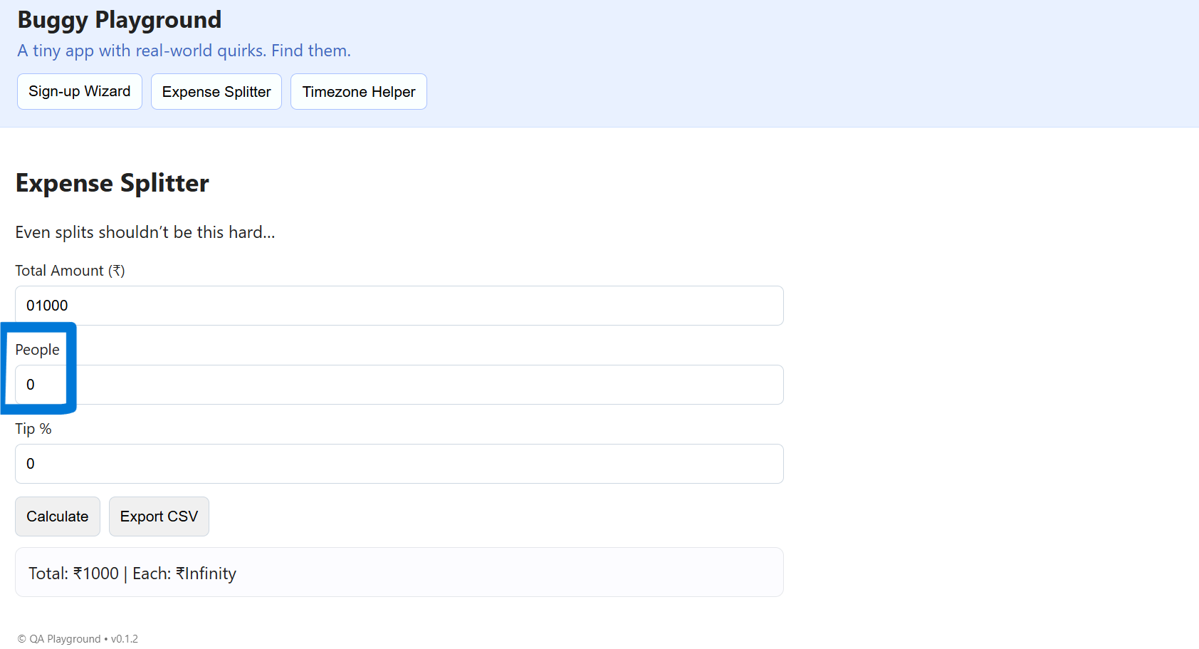

### **Bug #6: Incorrect Calculation with Decimal Input**

* **ID:** BUG-06
* **Severity:** High
* **Environment:** Windows 11, Chrome Browser
* **Steps to Reproduce (STR):**
  1. Navigate to the "Expense Splitter."
  2. Enter 1000 for "Total Amount" and 2.5 for "People."
  3. Click "Calculate."
* **Expected Result:** The application should either prevent decimal input for "People" or calculate the correct result (₹400).
* **Actual Result:** The application accepts the decimal input but performs an incorrect calculation, resulting in Each: ₹500.
* **Evidence:** 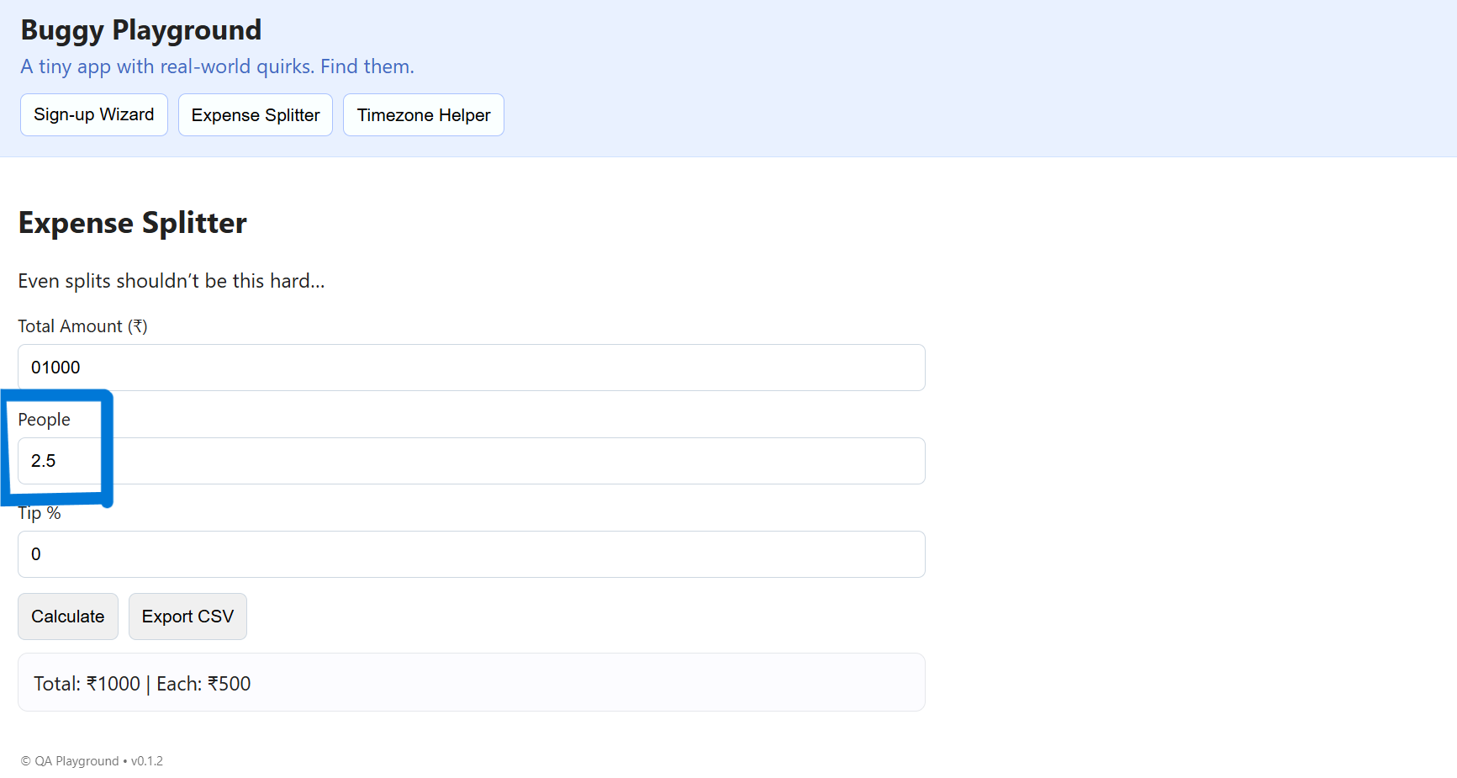

### **Bug #7: Accepts Negative "Total Amount"**

* **ID:** BUG-07
* **Severity:** High
* **Environment:** Windows 11, Chrome Browser
* **Steps to Reproduce (STR):**
  1. Navigate to the "Expense Splitter."
  2. Enter a negative number (e.g., -1000) in the "Total Amount" field.
  3. Click "Calculate."
* **Expected Result:** An error message should appear, stating that the amount must be a positive number.
* **Actual Result:** The application accepts the negative value and calculates a negative result.
* **Evidence:** 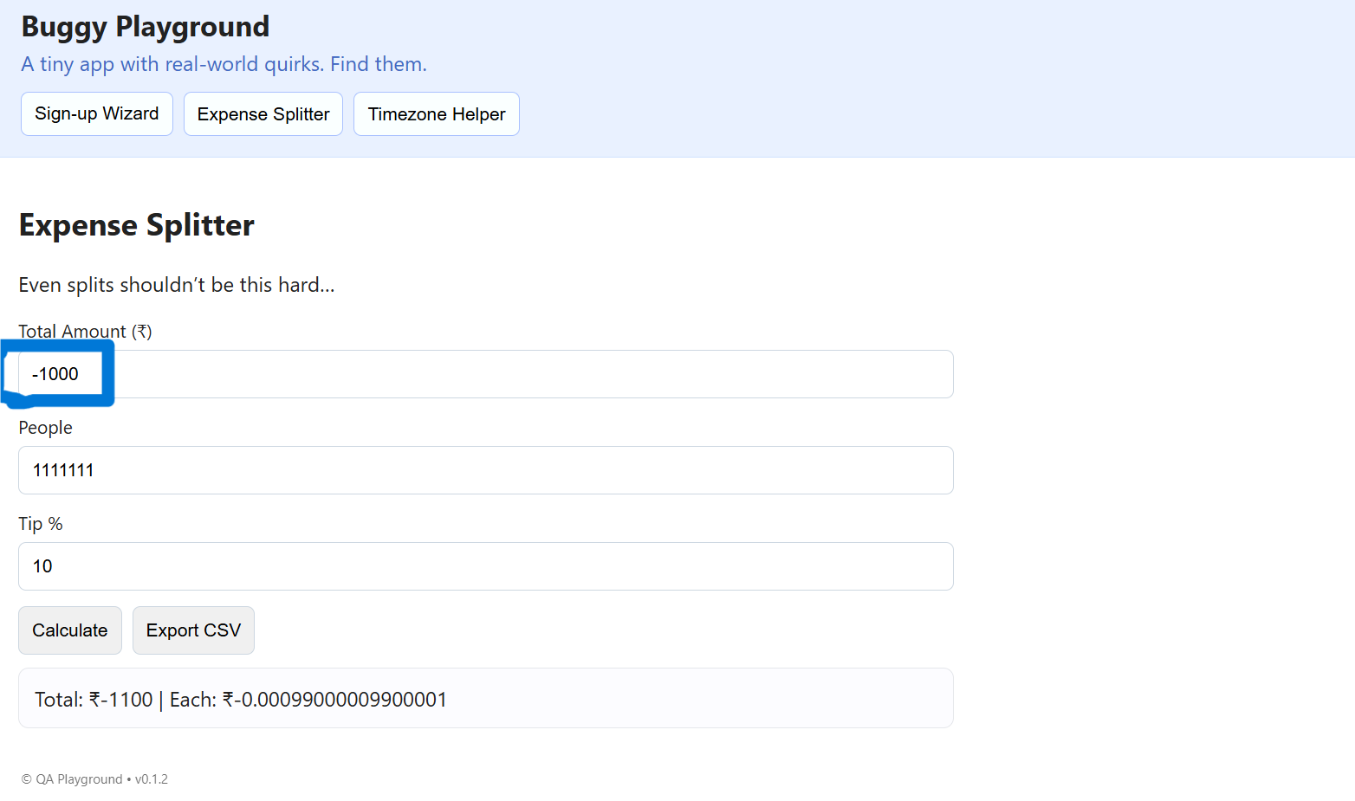

### **Bug #8: Accepts Negative "People"**

* **ID:** BUG-08
* **Severity:** High
* **Environment:** Windows 11, Chrome Browser
* **Steps to Reproduce (STR):**
  1. Navigate to the "Expense Splitter."
  2. Enter a negative number (e.g., -1111111) in the "People" field.
  3. Click "Calculate."
* **Expected Result:** An error message should appear, stating that the number of people must be positive.
* **Actual Result:** The application accepts the negative value and calculates a negative result per person.
* **Evidence:** 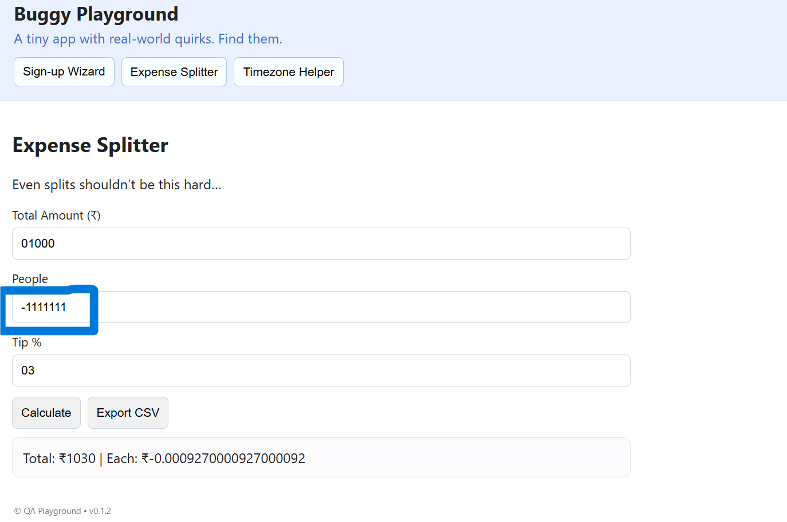

### **Bug #9: Accepts Negative "Tip %"**

* **ID:** BUG-09
* **Severity:** Medium
* **Environment:** Windows 11, Chrome Browser
* **Steps to Reproduce (STR):**
  1. Navigate to the "Expense Splitter."
  2. Enter a negative number (e.g., -10) in the "Tip %" field.
  3. Click "Calculate."
* **Expected Result:** An error message should appear, stating that the tip cannot be negative.
* **Actual Result:** The application accepts the negative value and incorrectly treats it as a discount, reducing the total amount.
* **Evidence:** 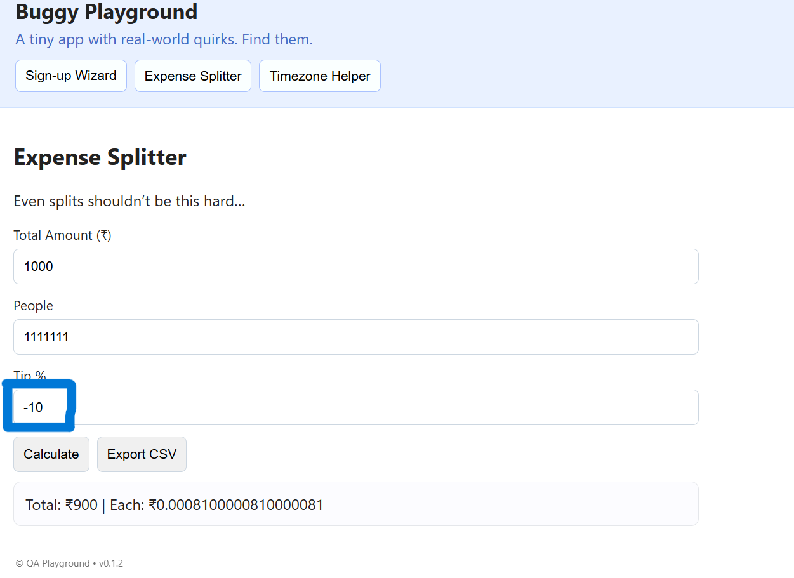

### **Bug #10: Accepts Non-Numeric Text as Input**

* **ID:** BUG-10
* **Severity:** Medium
* **Environment:** Windows 11, Chrome Browser
* **Steps to Reproduce (STR):**
  1. Navigate to the "Expense Splitter."
  2. Enter a non-numeric character (e.g., -) in the "Total Amount" field.
  3. Click "Calculate."
* **Expected Result:** An error message should appear, stating "Please enter a valid number."
* **Actual Result:** The application "fails silently" by interpreting the invalid input as 0 and shows a result of ₹0 without warning the user.
* **Evidence:** 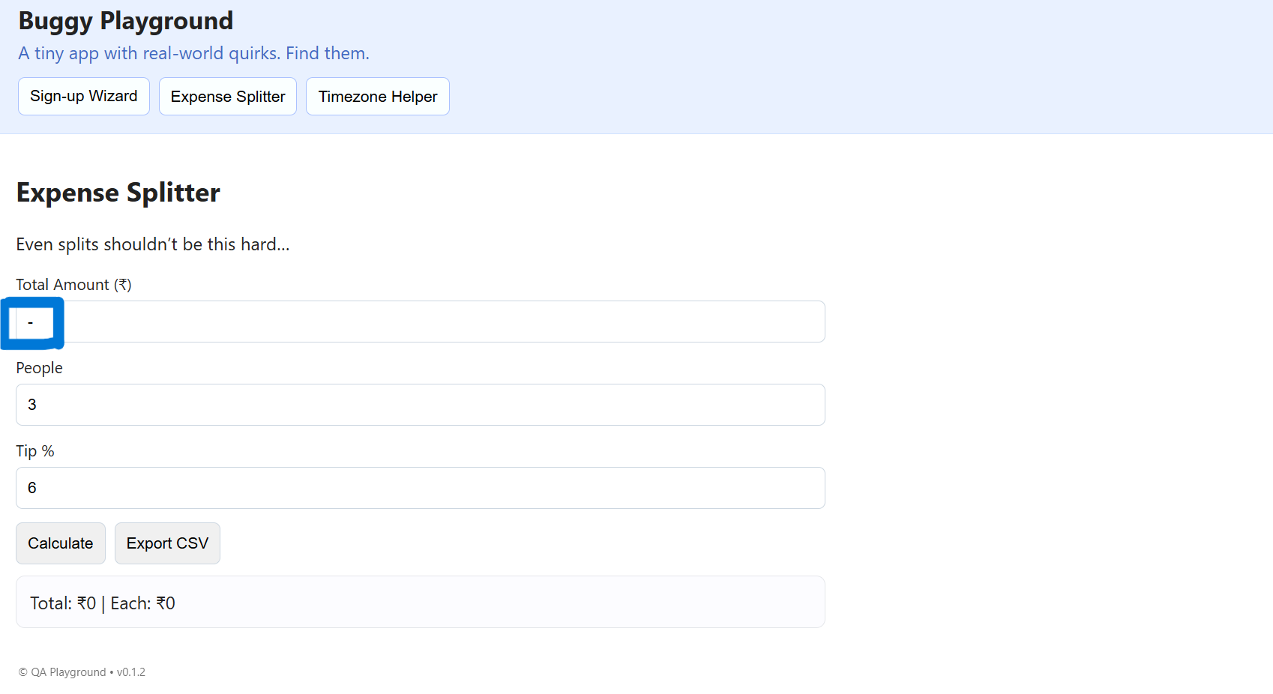

### **Bug #11: Timezone Helper Core Functionality is Broken**

* **ID:** BUG-11
* **Severity:** Critical
* **Environment:** Windows 11, Chrome Browser
* **Steps to Reproduce (STR):**
  1. Navigate to the "Timezone Helper."
  2. Enter a valid date and time (e.g., 13-09-2025 17:00).
  3. Select any "Target Zone" (e.g., America/New_York).
  4. Click "Convert."
* **Expected Result:** The application should display the correctly converted date and time for the selected target zone.
* **Actual Result:** The application fails to convert the timezone, calculates the time incorrectly, and keeps the output in the original "(India Standard Time)".
* **Evidence:** 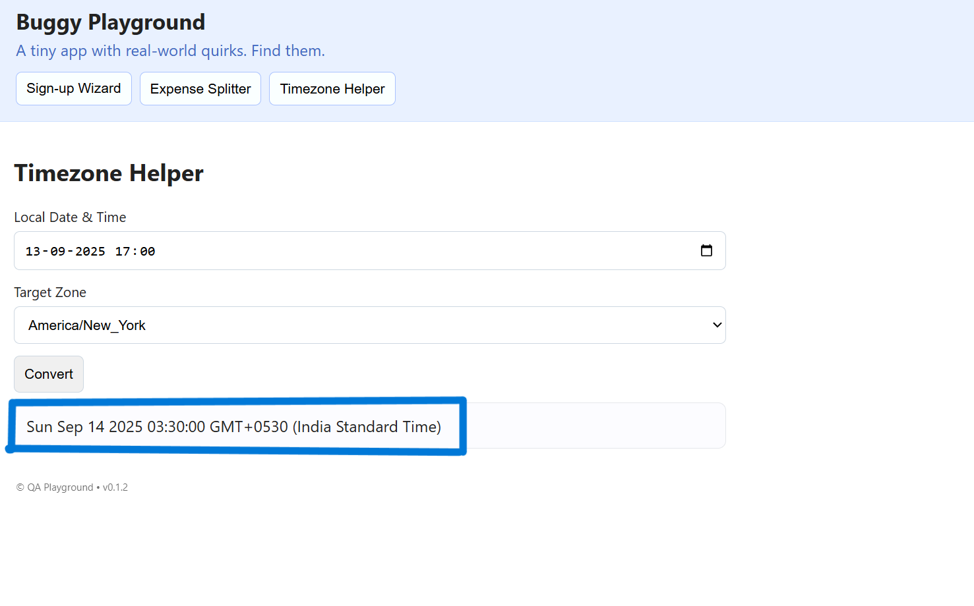

### **Bug #12: Timezone Helper Accepts Invalid and Boundary Dates**

* **ID:** BUG-12
* **Severity:** High
* **Environment:** Windows 11, Chrome Browser
* **Steps to Reproduce (STR):**
  1. Navigate to the "Timezone Helper."
  2. Enter an invalid or extreme boundary date (e.g., 01-01-0001).
  3. Click "Convert."
* **Expected Result:** The application should either show a validation error or handle the boundary date gracefully.
* **Actual Result:** The application accepts the date but produces a nonsensical result with a historically inaccurate timezone offset (GMT+0553), confirming the logic is deeply flawed.
* **Evidence:** 